**CLOUD COMPUTING DAY-3 QUESTIONS**

**USING AZURE**

**16. Create a Simple Web Application using Java or Python and host it in any Public Cloud Service Provider (Azure/GCP/AWS) to demonstrate Platform as a Service (PaaS)**

**Procedure:**

1.To open a azure website for student purpose and create a source->then go to web app application anc click that link.

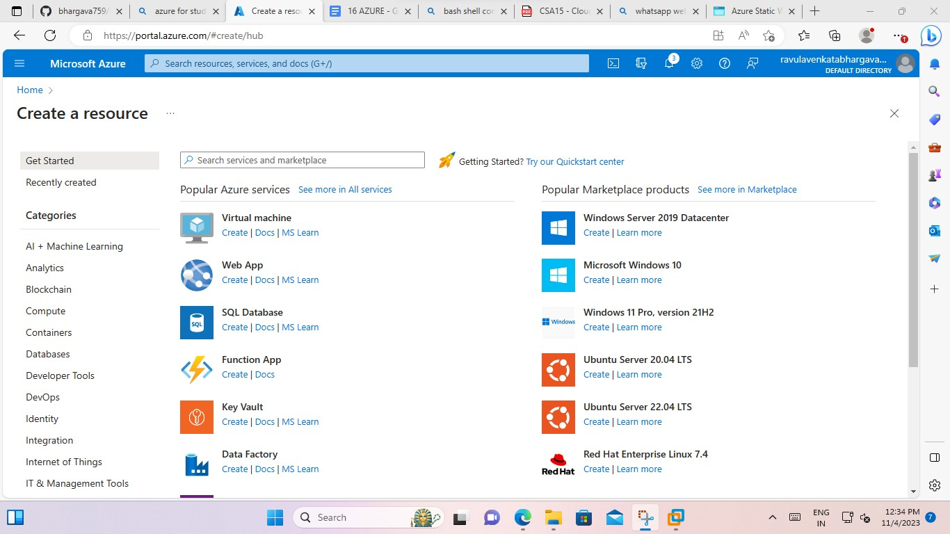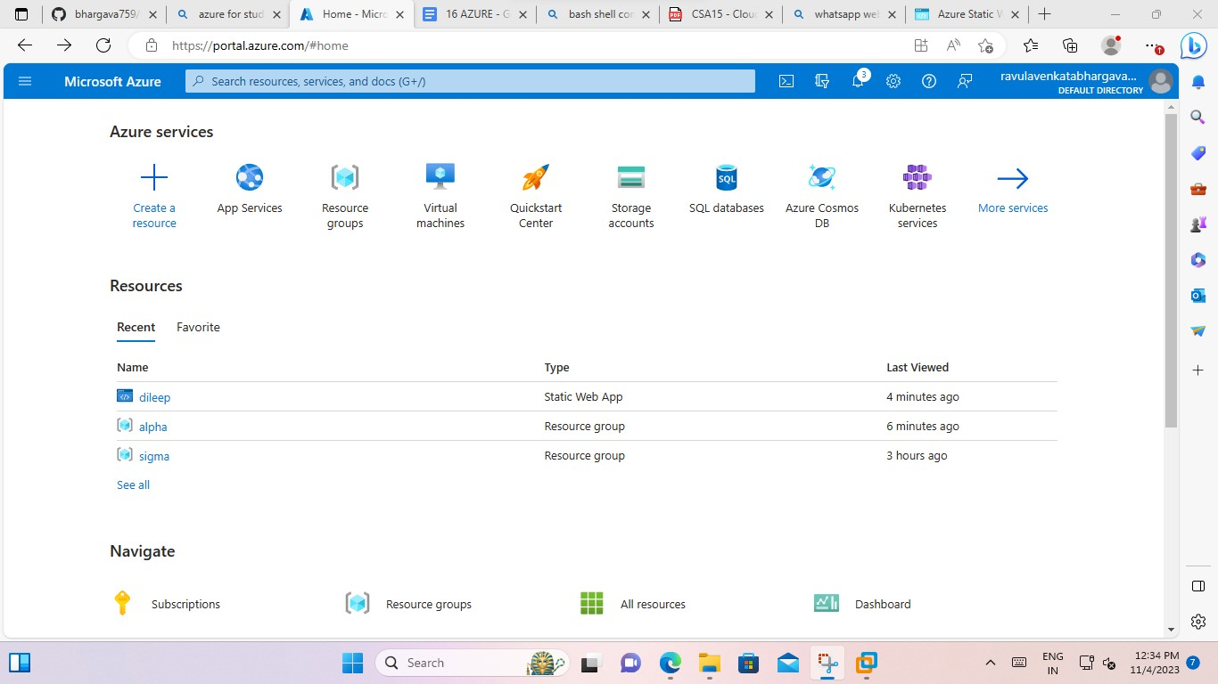

2.And then go to create an web app without impliment the code.

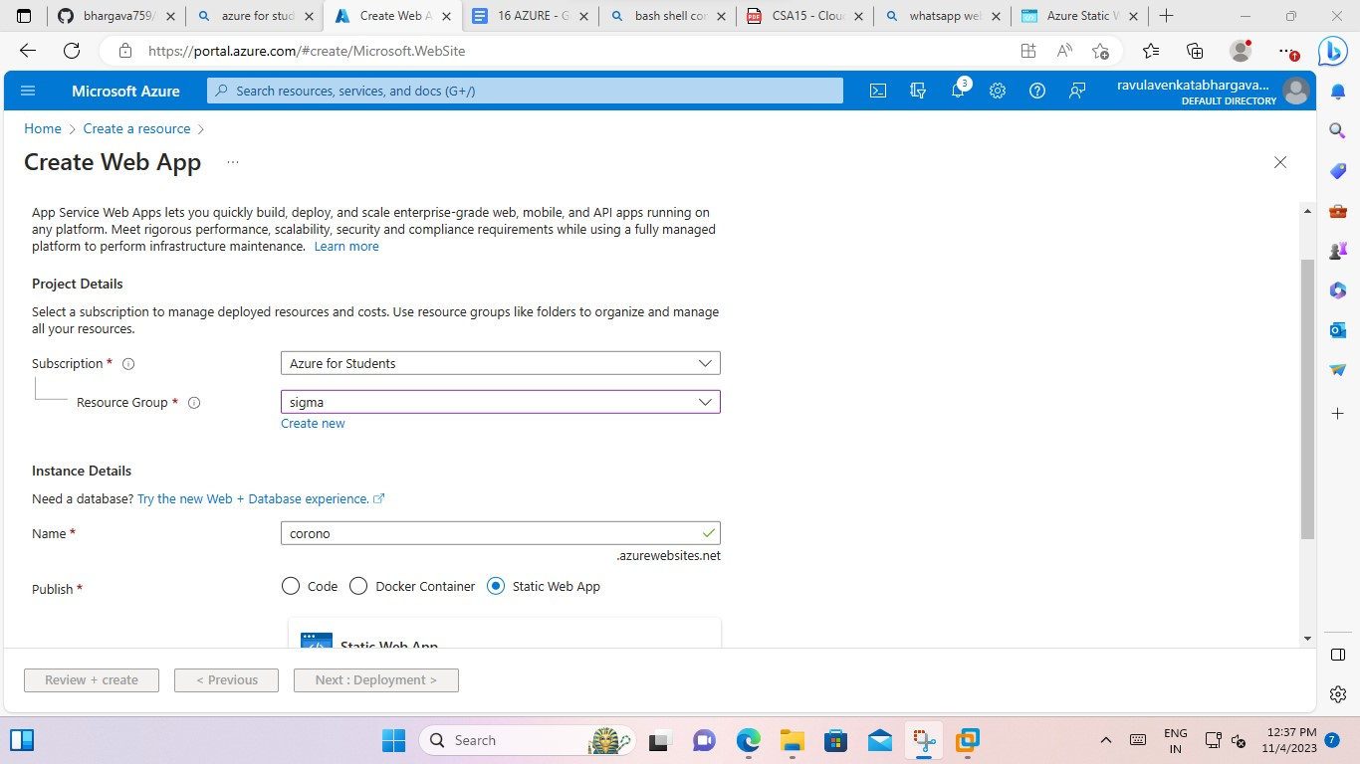

After enter the static web app it pop the one message and give just ok button.

3.and then give basic details

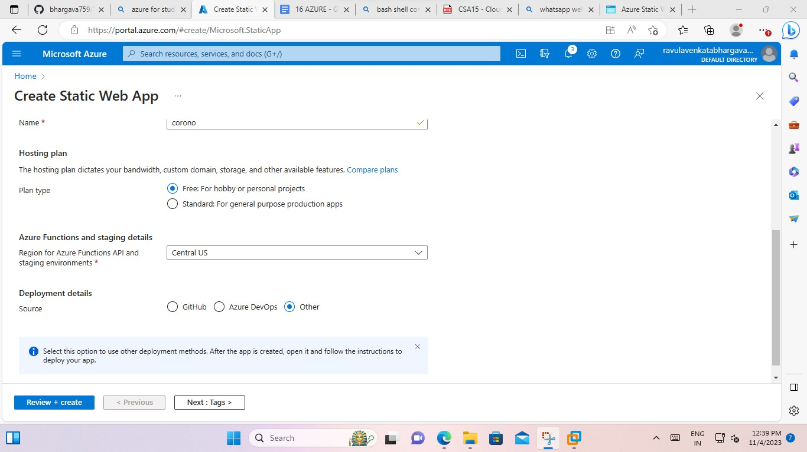

4.After go to the tags.

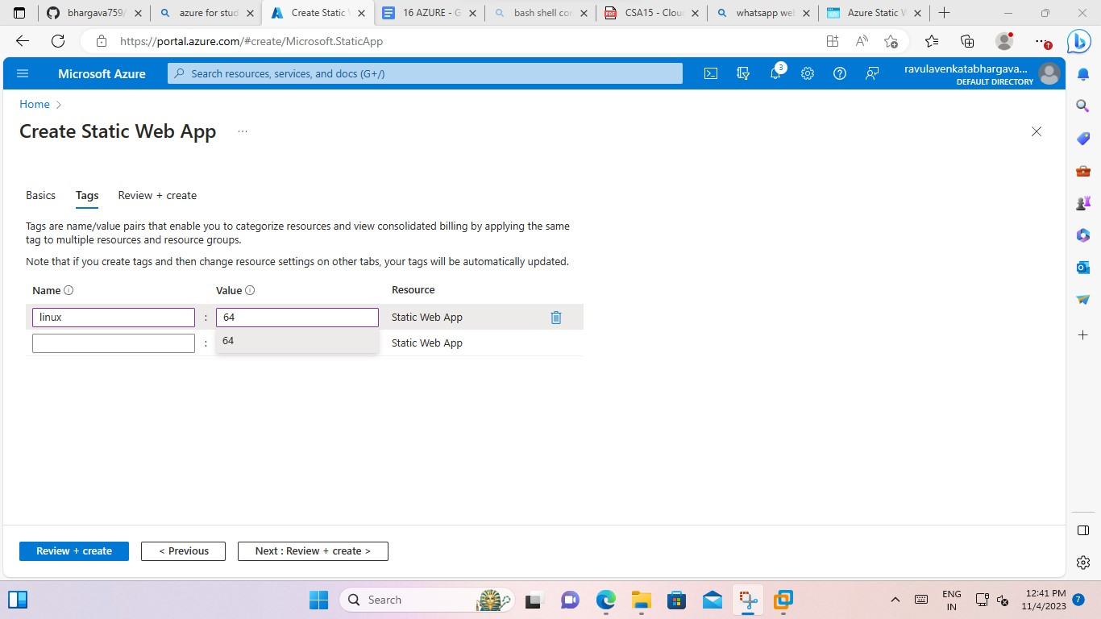

5. And after give the create button.

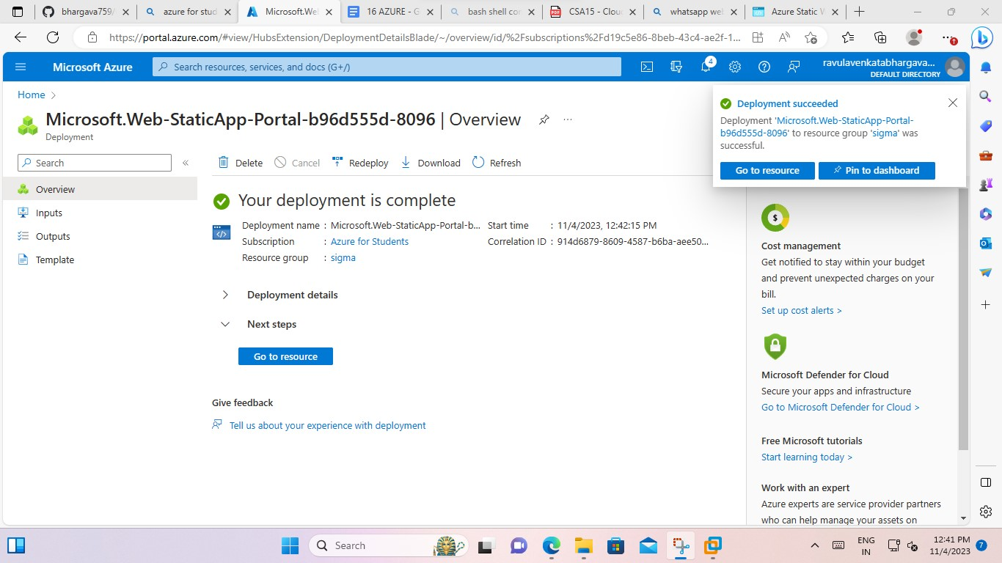

Go to resource for the given matter. To open means.

6.and copy the link of the static web app and paste the new browser.

